Chapter 9, Problem 72.

Calculate the value of Z_{ab} in the network of Fig. 9.79.

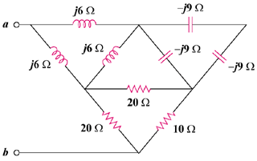

Figure 9.79
For Prob. 9.72.

